Natural Gas Price Predicting Adopting CNN-LSTM Hybrid Neural Network Model
Xinwei Fan *
Westdale Secondary School, Hamilton, Ontario, Canada
* Corresponding author: xfan4442@hwdsb.on.ca
Abstract. Natural gas price affects a lot in people’s daily expenses. Sudden change in natural gas influences people’s life to some extent. The study experiments and compares the CNN, LSTM, and CNN-LSTM hybrid model’s performance, and applies them to predict and forecast natural gas prices. CNN-LSTM model increases the number of neurons filters and use denser and deeper network structures. From the result, CNN-LSTM showed a significantly better reduction in average loss than a single model. The hybrid model also fitted a closer curve to the natural gas price line. The multivariate hybrid model gives more accurate result than the single model. The prediction method used in this paper can give better insight into evaluating natural gas price trends and provide people with ahead forecast of prices. The paper offers a basic reference to the direction of future improvements of model structures in further study.
Keywords: Machine learning, Deep learning, CNN-LSTM, Price forecasting.

Introduction
Natural gas is a necessary natural resource for people’s daily lives. The majority of people use natural gas for cooking, heating, and electricity. Though people’s demand for natural gas is static and inelastic, natural gas prices can be unstable and change quite a lot due to many social and international factors. For example, the US natural gas price on February 24, 2003, jumped to nearly 12 dollars per million btu and then decreased to almost 4.5 dollars per million btu on March 27, 2003. What’s more, the gas price reached the peak of 11.32 dollars per million btu on February 15, 2021, then shortly after that, it fell quickly back to 2.94 dollars per million btu on February 22, 2021. The sudden increase or decrease in the natural gas price will be passed on to the people’s daily expenses. This influences how much residents are going to spend on their regular bills. Since the natural gas price is closely related to people’s daily lives, it’s important and useful to give people a forecast of such expenses ahead of time or give and visualize a trend of how prices would go in the future.
To achieve such a forecast function, the algorithm is needed to capture, learn the pattern of price, and produce the possible resulting future natural gas price. Machine learning has been widely adopted in many fields, and some of its model and algorithm has shown great effect, especially in forecasting and prediction. In early studies, recurrent networks, such as RNN, and LSTM have already been used to predict outcomes of time series data. And CNN, SCNN are applied to extract the features with strides and skip connections between neurons. On the one hand, a single CNN is unable to learn the time-related pattern of inputs, on the other hand, a single LSTM may be disadvantaged to learn the pattern of unextracted features from data. To improve the performance of the network and to predict the multi-input features natural gas features, the study applied the hybrid model of CNN and LSTM. CNN-LSTM Hybrid model has shown great performance in handling time series data, such as weather forecasting, and share price predicting. In Taoying’s study, CNN-LSTM has been good in forecasting particulate matter [1]. Since the hybrid model in many studies has shown improvements in lowering loss average, the paper research how well multivariate CNN-LSTM can perform in predicting the natural gas price.
This paper explores and compares the improvement of the adopted CNN-LSTM hybrid model performance in predicting the natural gas price. Accordingly, this paper is divided into 4 sections to view this forecasting model implementation. Section 2 includes and describes the detailed methodology and algorithms used for the model, Section 3 provides results and discussion based on the model forecasting result. Section 4 gives a brief conclusion of the overall model application.

Methodology

Data Source Selection and Analysis
According to Sebastian Nick, natural gas prices have been influenced by external factors, crude oil prices, and coal prices [2]. Also based on EIA (Energy Information Administration), natural gas price is driven by internal parameters, amount of natural gas production, level of natural gas in storage, and volumes of natural gas imports and exports, variations in winter and summer weather, level of economic growth.
Weather conditions influence the price of natural gas indirectly, by affecting consumption of natural gas. Therefore, this study chooses the quantity of natural gas consumption as one of the indices.
Considering the overall growing trend of the economy and industry, the study chooses two indexes: the industrial production index (IPI) and the weekly Economic Index (WEI).
For other data parameters, we collect natural gas storage indicators, natural gas exports, and import data from the US Energy Information Administration (EIA).
Meanwhile, long-period prediction is impractical and inaccurate. So, in our approach, the study only takes 12 weeks of data as input and makes 1 week's future prediction.
Since data from thirteen years and earlier is less relevant to the current natural gas price changing pattern, we only include data from recent 13 years as samples.

CNN-LSTM Hybrid Model Structure
- Convolutional Neural Networks
Convolutional neural networks, namely CNN, is an advanced neural network based on the structure of ANN. Different from standard ANN, neurons in CNN are connected only to a specific region of the layer. It strides across the input array and operates the summation of element-wise multiplication products. CNN includes means of spatial strides, multi-filter operation, and padding. CNN in modeling is followed by a pooling layer, reducing the dimensions of the feature maps from CNN’s output [3].
The operation formula is as follows.

$y_{j}^{l}=f\left(\sum_{\left\{k∈M_{j}\right\}}^{ }{k_{j}x_{j}^{l}}+b_{j}\right)$ (1)

Where y denotes the output of the CNN layer, f denotes nonlinear activation, k denotes kernel’s weight entries, x denotes kernel, and b denotes bias.
Max pooling takes the output of the CNN layer, strides a kernel across the feature maps, and computes the maximum value within the range of the kernel. The maximum value is collected and reconstructed into a new feature map with smaller dimensions. This method is useful for scaling and resizing input.

$x_{j}^{l}=g\left(\begin{aligned}c_{j}^{l}max\left\{y_{i}^{l}\right\}+b_{j}^{l} \\ \end{aligned}\right)$ (2)

Where x denotes the input of the next layer, namely the final output of the current layer, g denotes nonlinear activation, c denotes weighted max pooling coefficient, and b denotes bias.
- Long-short-term Memory -LSTM
LSTM is a recurrent memory network based on RNN.
Recurrent neural networks are networks that have internal circular connections between neurons from different layers. RNN processes and computes the current data concerning data from past events. It possesses context cells to save outputs of hidden layers, and context cell data is fed forward along with input to the next hidden neurons. To predict from time series data, using RNN enables us to learn features of how natural gas prices change over time.
However, according to, the RNN model may bring up gradient vanishing or exploding issues. As time sequence length increases, the gradient of the recurrent layer in RNN grows exponentially [4].
Adopting LSTM is beneficial to deal with gradient vanishing problems. LSTM introduces memory blocks, with input and output gates connecting the input layer and other memory cells. The input gate is a sigmoid unit. A closed input gate has zero value. Parameters that control output gates can also be learned.
A LSTM implemented model operates the below functions.

$i_{t}=σ\left(W_{ii}x_{t}+b_{ii}+W_{hi}h_{\left\{t-1\right\}}+b_{hi}\right)$ (3)

$f_{t}=σ\left(W_{if}x_{t}+b_{if}+W_{hf}h_{\left\{t-1\right\}}+b_{hf}\right)$ (4)

$g_{t}=\tanh\left(W_{ig}x_{t}+b_{ig}+W_{hg}h_{\left\{t-1\right\}}+b_{hg}\right)$ (5)

$o_{t}=σ\left(W_{io}x_{t}+b_{it}+W_{ho}h_{\left\{t-1\right\}}+b_{ho}\right)$ (6)

$c_{t}=f_{t}⊙c_{\left\{t-1\right\}}+i_{t}⊙g_{t}$ (7)

$h_{t}=o_{t}⊙\tanh\left(c_{t}\right)$ (8)

Where h is the hidden state at t-1, c is the cell state, x is the input, g, f, i, o is cell, forget gate, input, output gates [5].
Moreover, to prevent overfitting on training data, the hybrid model introduces the dropout layer to LSTM, with a dropout probability of 0.1.
- LSTM-CNN Hybrid Architecture
The hybrid model contains two parts. The first part of the model consists of two CNN units each consisting of 2 convolutional layers and one maximum pooling layer, which generates feature maps, and gives extracted feature series to the LSTM layer. The second part of the model is a standard LSTM layer, which is responsible for processing time series data, followed by a dense layer that connects to the output [6].
The CNN layers adopt 2 convolutional 2D layers with kernel size 8*8, and the pooling layer operates max pooling.
The input of our CNN network is in the shape of 12*10. The output vector from the final dense layer is a one-dimensional vector array with a shape 1*1 representing the forecasted natural gas price for the following week. Fig. 1 shows the structure of the model. After the features are extracted from the CNN layers, the flattened output is passed on to the intermediate recurrent unit. Then following the recurrent unit, we have the dense layers that connect to the final output prediction vector.

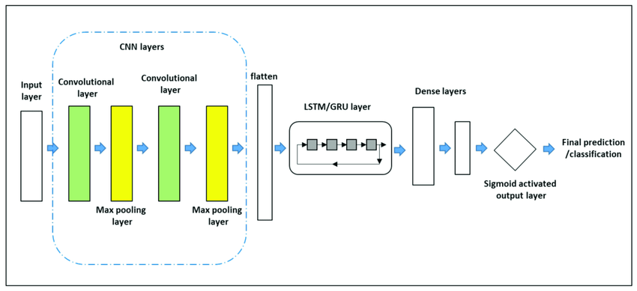
Figure 1. The structure of the model.

Loss Function
The model adopted three loss functions at different experiment trials. Mean absolute error calculates the sum of the absolute difference between the estimated output and the labeled vector. The formula for the calculation of MAE is shown below. Here yi denotes the lab labeled vector y, and y-hat denotes the estimated output, n denotes the total runtime.

$MAE=\frac{1}{n} \sum_{i=1}^{n}{|y_{i}-\hat{y_{i} }}|$ (9)

To get the measurement of how much each deviation is, we used the mean absolute percentage error. The mean absolute percentage error expresses the accuracy of output by measuring the sum of the ratio of deviation and labeled vector. At denotes the actual value, and Ft denotes the model output, n denotes the total runtime.

$MAPE= \frac{1}{n}\sum_{t=1}^{n}{|\frac{A_{t}-F_{t}}{A_{t}}|}$ (10)

The study also applied root mean square error (RMSE) to get the more complex gradient of the loss function. RMSE computes the square root of L2 loss. It’s mostly used for time series data. Here y hat denotes the estimated output, and yi denotes the labeled vector, n denotes the total runtime.

$RMSE= \sum_{i=1}^{n}{\frac{(y_{i}^{^}-y_{i}) ^{2}}{n}}$ (11)

Comparison Models and Hyperparameters
To prove the necessity and optimization of the CNN-LSTM hybrid model, we also adopted a single CNN and LSTM model.
During the process of training, we adopted the grid search, and Bayesian optimization * to search for the best combination of hyperparameters.
The model’s activation function also uses the SiLU, and through pre-training, the paper found that ReLU will cause the gradient to vanish or explode.

Result and Discussion
The paper trained the comparison model and the hybrid model on the same dataset to predict natural gas prices.
Fig. 2 shows the gas price prediction curve produced by CNN, LSTM, and the hybrid model. Graph (a), (b), (c) are CNN prediction, LSTM prediction, and Hybrid prediction respectively Here the x-axis represents the trial in time order, the y-represents the natural gas price in dollars, the orange curve denotes the labeled natural gas price, and the blue curve in each graph denotes the individual prediction of each model in the testing dataset. As it is clearly illustrated, the hybrid model has a closer fitting with the labeled graph. CNN is good at fitting the amplitude of the curve, while LSTM can forecast the trend well, and the hybrid model captures the advantage of both.
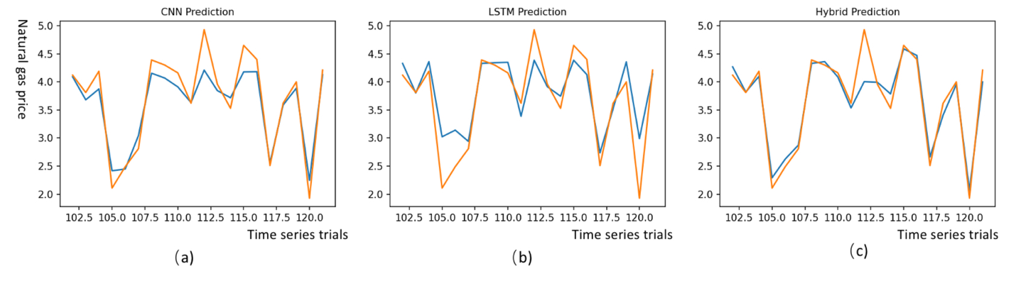
Figure 2. Prediction versus label diagrams of CNN, LSTM, Hybrid model.
The following Table 1 presents and compares the number of neurons, learning rate, loss functions, and number of training times of each model. The hybrid model by introducing two types of neural layers, has increased the number of neurons, and filters. This helps to extract and capture hidden features.
Table 1. Model Summarization
Model | # of Neurons | Learning rate | Loss function | Number of training times
CNN | 727 | 0.01 | L1Loss | 50
LSTM | 2540 | 0.01 | L1Loss | 50
Hybrid | 5,337 | 0.001 | L1Loss | 50

Table 2 presents the evaluation metrics results of each model after training. The hybrid model compared to other models has reduced the mean average error to 202.7, whereas CNN has a mean average error of 261.4, LSTM is 394.9, meaning that the hybrid model has a reliable performance in reducing the average L1 Loss.
Table 2. Model Evaluation
Model | Evaluation Metrics
Model | MAE | MAPE
CNN | 261.4 | 0.06
LSTM | 394.9 | 0.1
Hybrid | 202.7 | 0.19

Conclusion
With all the aspects discussed above, the study has applied deep learning models to forecast the price of natural gas. In particular, the study not only considered the historical data of natural gas prices, but also kept track of external factors such as WEI, and IPI. And different from previous research, the paper adopted combinations of the convolutional model and time-series recurrent model to learn the features from both the time dimension and lateral features dimension. The CNN-LSTM experiment in the paper has shown improvement compared to a single model. CNN-LSTM model increased the number of filter neurons, and the complexity of the model structure, demonstrating a better capture of hidden features. And the average loss of the prediction value has been significantly lowered by CNN-LSTM, compared to CNN, LSTM single model, indicating the superior performance of the hybrid model in predicting and fitting natural gas price data. In total, by adapting the CNN-LSTM model, the study found a more precise approach to fit the natural gas price data curve.
Meanwhile, the study results have limitations. The study only considers the 8 main indices to indicate how the curve of natural gas price is influenced. Also, the limited number of iterations, and network neurons, can cause the inaccuracy of the study results. While this paper investigates the improvements of the hybrid model in predicting natural gases, further study of network structures is required to gain more insight into best-fitted model in this forecasting, concerning this paper’s quantitative and qualitative analysis.

References
- Taoying Li, Miao Hua, and Xu Wu. A Hybrid CNN-LSTM Model for Forecasting Particulate Matter (PM2.5), in IEEE Access, 2020, 8, 26933 - 26940.
- Sebastian Nick, Stefan Thoenes, Institute of Energy Economics, what drives natural gas prices – A structural VAR approach, Energy Economics, Science Direct.201, 517 - 527.
- Keiron O’Shea, Ryan Nash, An Introduction to Convolutional Neural Network, in Arxiv access, 26 Nov 2015, doi: 10.48550/arXiv. 1511. 08458.
- Seol Hyun Noh, Department of Statistical Data Science, ICT convergence engineering, Anyang University, Analysis of Gradient Vanishing of RNNs and Performance Comparison, 2021, 12 (11), 442.
- Ralf C. Staudemeyer, Eric Rothstein Morris. Understanding LSTM- a tutorial into Long Short-Term Memory Recurrent Neural Networks, Faculty of Computer Science, Schmalkalden University of Applied Science Germany, in Arxiv access, September 23, 2019.
- Yan Li, Wei Dai, Department of Financial Engineering, Central University of Finance and Economics, Beijing, People’s Republic of China, Bitcoin price forecasting method based on CNN-LSTM hybrid neural network model, 2019, 19.

