Forecasting China's Real Estate Investment Trends: A Dynamic Regression Model Approach with ARIMA
Haoyuan Chen *
WMG, University of Warwick, Warwick, United Kingdom
* Corresponding author: haoyuan.chen@warwick.ac.uk
Abstract. This investigation utilizes a dynamic regression model with Autoregressive Integrated Moving Average (ARIMA) error correction to evaluate and forecast the trajectory of China's real estate market. The model interprets investment cycles, indicating an imminent significant peak and anticipates subsequent market adjustments. The research integrates key indicators such as production output and sales data to substantiate its predictions, simultaneously warning of an overinflated housing market due to shifting demands and demographic evolution. The authors argue for a more sophisticated modeling approach to accurately reflect the market's nuances and propose targeted policy measures aimed at maintaining equilibrium. The study presents the model's formidable forecasting ability while also acknowledging the complex, multifaceted nature of the real estate sector which mandates ongoing model enhancements. This dual focus on predictive accuracy and the call for adaptive modeling underscores the study's commitment to providing actionable insights in a rapidly changing economic landscape. The proposed policies seek to preemptively counteract instability, thereby contributing to a more sustainable real estate economy in China.
Keywords: China real estate market, dynamic regression model, ARIMA model, housing investment trends.

Introduction
Over the past four decades, since the landmark reforms that opened China's markets, the country's real estate sector has become an economic titan, now accounting for a staggering 30% of the nation's GDP. This remarkable figure underscores the intense focus on infrastructure and urban development that has been a hallmark of China's economic strategy. However, this dependency also poses significant risks, as exemplified by the recent real estate sector upheavals.
The global economic landscape was profoundly transformed by the 2008 U.S. subprime mortgage crisis, rooted in the collapse of a housing bubble exacerbated by real estate asset securitization [1]. China's property market faces similar challenges, particularly in the wake of a pandemic that has seen prominent developers like Evergrande Group amass unsustainable debts, leading to defaults and insolvencies. This trend of overexpansion has precipitated unfinished housing projects, leaving buyers adrift and severely denting confidence in the real estate market. Without intervention, this pattern may spiral into widespread asset depreciation, bursting of the real estate bubble, and an ensuing economic downturn [2].
This paper endeavors to predict the trajectory of real estate investment in China, scrutinizing whether the current surplus in housing will endure and the extent to which it may precipitate a sharper market downturn. It questions whether government regulatory policies should be recalibrated, whether economic stimulus is required to invigorate housing demand, or if constraints on property development are necessary to prevent overexpansion.
An extensive review of existing literature reveals the dynamic regression model (DRM) as a preferred tool for real estate analysis and forecasting, praised for its responsiveness to immediate market indicators. Seokyon Hwang's research demonstrated the DRM's effectiveness in predicting construction costs, attributing its success to the model's integration of contemporary data points, allowing for rapid updates to projections [3]. Yu Wei's approach, applying the DRM to China's housing price trends, underscored the model's superiority over traditional methods, with its flexibility and evolving coefficients providing a more nuanced forecast [4]. In international contexts, such as the work of Francesco Tajani and his team on Spain's housing bubble, DRMs were lauded for their statistical robustness and the clarity of the models they produced [5].
In a departure from the macroeconomic focus of Nzalu Francis Muli's research, which highlighted GDP, interest, and inflation rates as significant influencers of real estate investment in Kenya [6], this paper studied probes deeper. This paper considered the direct costs of real estate development by including data on cement, steel, and aluminum production to assess the practicality of real estate projects. This approach is informed by Melchior Sawaya Neto's insights on the often-neglected aspects of land, materials, and labor costs [7]. This paper analyzed notes a paradigm shift in investment motivations, from price sensitivity in the early 1990s to cost-centric considerations in subsequent years, suggesting a more sophisticated investigation into housing price expectations and alternative modeling approaches is warranted. Additionally, the study integrated the M2 money supply indicator, capturing the expanse of housing provident fund loans, as a reflection of Chinese purchasing power within the property market [8]. Alongside this, this paper considers housing sales data as a direct measure of market demand, shaping property developers' forecasting and planning.
This paper presents a comprehensive analysis, utilizing robust data to project trends in real estate investment while considering both supply-side costs and demand-side pressures, alongside broader macroeconomic conditions.

Methods

Data Source
In the quantitative assessment, this paper has leveraged the official statistical data sanctioned by the National Bureau of Statistics of China. The author has systematically selected six variables that are critical to the comprehensive analysis of real estate investment dynamics. This paper’s analytical model positions real estate infrastructure investment as the dependent variable, which is critically influenced by three supply-side variables: the output of steel, aluminum, and cement. These variables are essential in quantifying and understanding the investment patterns within the real estate sector.
Moreover, this paper has included the M2 money supply as a macroeconomic proxy, reflecting the purchasing power of potential real estate buyers and their ability to procure property, which informs the demand side of the market. Sales volume in the real estate sector is also scrutinized, offering a granular view of market demand and enabling us to infer the corresponding strategic forecasts and investment plans of property developers.
The prognostic model, composed of one dependent and five independent variables, is utilized to project future real estate investment volumes. This paper has harnessed monthly data spanning 184 points for each variable, a dataset enriched by its inclusion of major economic milestones such as the 2008 financial crisis and the 2019 COVID-19 pandemic. This substantial time frame allows for a robust predictive framework that considers supply and demand dynamics as well as broader economic conditions.

Methodological Rigor
The initial step involved applying the Kwiatkowski-Phillips-Schmidt-Shin (KPSS) test to the author’s selected variables, operating under the hypothesis of stability within the dataset. The findings indicated p-values below the 5% threshold for both independent and dependent variables, signifying non-stationarity and necessitating further data transformation [9]. Logarithmic adjustments followed by differencing were undertaken, which, upon retesting, produced p-values exceeding 5%, thus confirming the stabilized condition of the variables for subsequent predictive modeling (Table 1).

Table 1. KPSS test results
KPSS | p-value | Sig level
Log Dif of Investment | 0.1 | >0.05
Log Dif of Steel Production | 0.1 | >0.05
Log Dif of Aluminum | 0.1 | >0.05
Log Dif of Concrete | 0.1 | >0.05
Log Dif of M2 | 0.1 | >0.05
Log Dif of Housing Sales | 0.1 | >0.05

Results and Dsiscussion

Dynamic Regression Model
In constructing the forecasts, the author introduced a dynamic modeling framework capable of incorporating a vast array of influential factors, thereby accommodating the complexities inherent in China's real estate investment landscape. The inclusion of covariates such as production metrics for concrete, steel, aluminum, coupled with financial indicators like money supply and housing sales, facilitated the creation of a dynamic regression model. This model adeptly encapsulates the intricate economic, financial, and market dynamics at play.
The equation for this dynamic regression with an ARIMA (1, 0, 0) (1, 0, 0):

$Y_{t}=β_{0}+β_{1}X_{1,t}+β_{2}X_{2,t}+β_{3}X_{3,t}+{β_{4}X}_{4,t}{+{β_{5}X}_{5,t}+ε}_{t}$ (1)

$ε_{t}=ϕ_{1}ε_{t-1}+Φ_{1}ε_{t-11}+a_{t}$ (2)

In examining the 'lli' series—presumed to reflect fluctuations in housing investment—through the lens of an ARIMA model, this paper is able to dissect how historical patterns and seasonal trends play into current forecasting. This time-sensitive analysis is crucial in parsing out how past data points inform present expectations, particularly in a market as dynamic as real estate.
To validate the efficacy of this model, the Ljung-Box test has been employed on the model's residuals, which are essentially the deviations between the actual data and the model's forecasts. This test is a measure of randomness, checking for leftover patterns that the model may have missed. A statistic of 21.032 and a p-value of 0.3952 from the test bring reassuring news: there's no significant sign of autocorrelation, meaning the residuals don't exhibit any discernible patterns across 22 lags. In layman's terms, the model is doing a good job; the forecasts it generates aren't systematically off the mark, and any errors don't seem to follow a predictable path that the model is consistently missing (Figure 1).
A p-value that's lower than the usual 0.05 cut-off would normally be cause for concern, indicating that the model's residuals have some degree of autocorrelation and thus, the model isn't fully capturing the nuances of the dataset. But here, the higher p-value reassures us that the residuals are distributed randomly, underscoring the model's capacity to account for the underlying autocorrelation in the housing investment data.
The combined picture these analyses paint is one of confidence in the model's ability to forecast housing investment trends, taking into account the inherent temporal fluctuations. It's a testament to the model's soundness that the residuals— the yardstick for accuracy—are as close to random as this paper can hope, suggesting that the ARIMA model's insights are well-founded and reliable for interpreting past trends to predict future movements in the housing market.
In this study, the model shows us how different factors are connected to housing investment. For example, when steel production goes up, housing investment tends to go down.[10] On the other hand, when more concrete is produced, it seems to boost housing investment. Changes in aluminum production don’t really have a big impact either way. However, when housing sales increase, there's a strong chance that housing investment will rise too. Interestingly, when there's more money available in the economy (M2 money supply), housing investment surprisingly tends to drop, which is not what the common sense might expect.
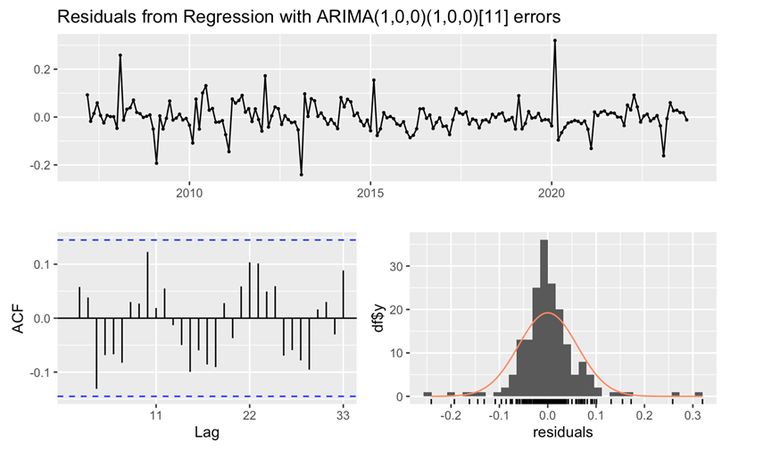
Figure 1. Residual check for the ARIMA model
The model fits the historical data well, as seen by some technical statistics that tell us the model's predictions are generally reliable and not overly complicated. It's pretty accurate in its forecasts, which might because the errors in its predictions are quite small. But there are some areas where the model doesn't do as well, like some predictions being off by a larger margin. This is flagged by two measures, MAPE and MASE, suggesting that the model's accuracy isn't consistent across all cases and that sometimes it might not do better than a simple guess.
In simple terms, the model really highlights how much housing sales can impact housing investment and points out an unexpected effect where more money in the economy might lead to less housing investment. While the model is good at following past trends, the issues with some predictions being off by quite a bit mean this paper should be a bit careful about relying on it without considering the possibility of unusual or unexpected changes in the market.

Forecast for Independent Variables
For next step, this paper proceeded to forecast the independent variables, employing various forecasting methods including the mean method, naive method, seasonal naive method, random walk with drift model, Holt's method, Holt's damped method, and the simple exponential smoothing model. The author conducted an 11-month forecast for the five variables and assessed their accuracy to select the most suitable forecasting model. The forecasts were then incorporated back into this paper’s dynamic model.
In predicting the log difference of steel production, concrete production, M2 supply, and housing sales, the seasonal naive method emerged as the most accurate, yielding the lowest RMSE values of 0.05162, 0.1350374, 0.00909209, and 0.1070252, respectively. For the log difference of aluminum production, Holt's damped method demonstrated the lowest RMSE, indicating its superior predictive performance for this particular variable. Consequently, the author selected the corresponding forecast data as the predictive inputs for the dynamic model (Table 2).

Table 2. Dynamic model variables
Model | Steel | Aluminum | Concrete | M2 | Housing Sales
Mean | 0.06 | 0.08 | 0.17 | 0.02 | 0.77
Naïve | 0.09 | 0.12 | 0.26 | 0.02 | 1.21
S-naïve | 0.05 | 0.06 | 0.14 | 0.01 | 0.1
RWFDrift | 0.09 | 0.08 | 0.26 | 0.02 | 1.21
Holt | 0.06 | 0.06 | 0.17 | 0.02 | 0.79
Holt-Drift | 0.06 | 0.05 | 0.17 | 0.02 | 0.78

Model Results
The presented graph elucidates the time series forecast for housing investment in China, utilizing a dynamic regression model enhanced by ARIMA (1, 0, 0) (1, 0, 0) [11] errors. The underlying historical data, marked by the black line, reveals a consistent pattern attributed to seasonal influences, which have been factored into the predictive analysis. The model's forecast, delineated by the blue line, suggests a perpetuation of this established cyclical trend. Noteworthy within the forecast is a pronounced peak toward the end of the projection period, accompanied by a broadening confidence interval, indicative of heightened uncertainty in the estimations.
This peak, particularly discernible in the blue forecast line, may presage a pivotal inflection in housing investment, shaped by key factors including the outputs of steel, aluminum, and concrete production, the breadth of M2 money supply, and the volume of housing sales. The narrowing confidence intervals observed in the proximate data signify a stronger predictive certainty, while the divergence seen in the long-range forecast underscores the increasing speculative nature of these projections.
The projected uptrend in housing investment, aligning with historical patterns, is expected to manifest robustly, driven by the seasonal momentum of the construction industry. Typically, a slower onset of construction activity is seen during the colder months, owing to environmental impediments and festive breaks. However, as the climate becomes more conducive, the industry is anticipated to surge, entering a period of intense activity. Despite the model not forecasting a dip beneath historic lows, thereby implying a baseline stability in housing supply, it does not discount the possibility of sharp declines in demand triggered by macroeconomic upheavals or demographic transitions, such as population aging and fertility rate reductions. Should such a scenario unfold, it may precipitate an oversupply in the housing market, risking the integrity of a speculated real estate bubble and the subsequent devaluation of assets, which could spiral into a broader economic recession.
This predictive outlook, grounded in statistical modeling and economic theory, underscores the importance of vigilance and adaptability in policy planning. It advocates for a proactive approach in managing the real estate market, emphasizing the need to balance supply with evolving demand, to mitigate the risks of market volatility, and to safeguard the economic well-being of the nation. The insights from this model are integral to informing strategic economic decisions, enabling stakeholders to navigate the complex interplay of market forces and to preempt potential downturns in the housing sector and the overall economy (Figure 2).
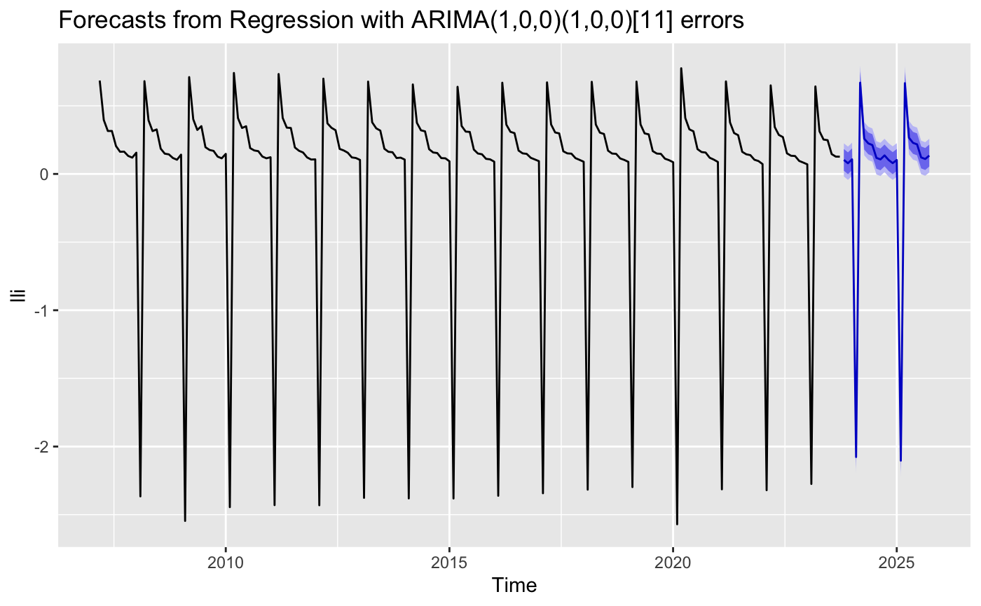
Figure 2. Forecast for log difference of investment in housing.

Conclusion
The dynamic regression model, leveraging ARIMA methodologies, provides a comprehensive review of China's real estate market, revealing ingrained seasonal investment patterns and predicting sustained cyclical behavior. Notably, it forecasts a significant forthcoming peak in investment activity, although these projections are not without their degree of uncertainty. The model illustrates how investment cycles are shaped by various factors, including production levels of cement, steel, aluminum, the availability of monetary supply, and housing sales data. These elements, indicative of market stability, also hint at a looming real estate bubble, potentially inflated by erratic demand and demographic shifts.
The model’s forecasts underscore the necessity for incorporating seasonal influences such as climatic variations and holiday periods to more accurately assess future market tendencies. Furthermore, it sheds light on the potential impact of variables not thoroughly considered in the current model, like birth rates, per capita GDP, loan amounts, energy costs, and average earnings, suggesting that these factors could significantly refine future predictions.
Acknowledging the inherent uncertainties within dynamic regression modeling, this paper’s findings support the strategic use of such models for future forecasting. Based on the anticipated accuracy of these projections, the author advocates for governmental measures to foster a stable demand within the real estate market to prevent the perilous consequences of a bubble burst. Proposed short-term interventions include easing restrictions on urban property purchases, incentivizing home acquisition in smaller cities, and reducing loan down payment ratios to stimulate the market.
For long-term market stability, the model encourages initiatives to promote population growth and adapt housing constructions to cater to the needs of an aging demographic, thereby stabilizing demand. In scenarios where the costs of controlling demand are exorbitant, a contraction of the supply side, enforced through policy measures such as land sale limitations and capping real estate enterprise loans, might be necessitated to preempt market trends and stave off a potential crisis.
The actionable insights derived from this paper’s dynamic regression model with ARIMA errors serve not only as a forecast but as a catalyst for policy innovation, aiming to maintain equilibrium in the real estate market and, by extension, the broader economy. This model becomes a crucial instrument for policymakers, providing a granular view of the housing market's intricacies and offering a strategic foundation for preemptive and corrective economic measures.

References
- Coffee J C. What Went Wrong? An Initial Inquiry into the Causes of the 2008 Financial Crisis. J. Corp. Law Stud., 2009, 9: 1 – 22.
- Zhi T, Li Z, Jiang Z, Wei L, Sornette D. Is there a housing bubble in China? Emerg. Mark. Rev., 2019, 39: 120 – 132.
- Hwang S. Dynamic Regression Models for Prediction of Construction Costs. J. Constr. Eng. Manag., 2009, 135: 360 – 367.
- Wei Y, Cao Y. Forecasting house prices using dynamic model averaging approach: Evidence from China. Econ. Model., 2017, 61: 147 – 155.
- Tajani F, Morano P, Saez-Perez M P, Di Liddo F, Locurcio M. Multivariate Dynamic Analysis and Forecasting Models of Future Property Bubbles: Empirical Applications to the Housing Markets of Spanish Metropolitan Cities. Sustainability, 2019, 11: 3575.
- Muli N F. An Assessment of the Factors Affecting the Growth in Real Estate Investment in Kenya. Theory Soc., 2013, 1 - 66.
- Neto M S. Analysis of the Determinants of New Housing Investment in Spain. Hous. Theory Soc., 2005, 22: 18 – 31.
- Lastrapes W D. The Real Price of Housing and Money Supply Shocks: Time Series Evidence and Theoretical Simulations. J. Hous. Econ., 2002, 11: 40 – 74.
- Hobijn B, Franses P H, Ooms M. Generalizations of the KPSS-test for stationarity. Stat. Neerlandica, 2004, 483 – 502.
- Huang S, Shin S W, Wang R D. The Impact of Housing Price on the Performance of Listed Steel Companies Evidence in China. Asia-Pac. J. Bus., 2020, 11: 27 – 43.

